Personal profile

Name Callum Jaydon Harper

Student email [S3815868@student.rmit.edu.au](mailto:S3815868@student.rmit.edu.au)

Student id S3815868



Hello everyone my names Callum, just a little bit about myself I grew up in rural east Gippsland in Victoria I have lived in the country all my life, I am 20 years old, I have been home-schooled all my life up until university I also have 2 brothers a twin brother and a little brother both of which were home-schooled with me.

Some of my previous education after school is I have a diploma of financial planning and I’m currently in my second year of my bachelor’s degree of business and finance, so I’m quite new to this whole IT scene but I’m prepared to learn as its such a huge part of the world and especially business world around us.

outside of studying my hobbies are sports and music and the gym (pretty basic I know)

My interest in IT started I guess when I started learning about business, everything we do from trading a share online or making a new business all requires IT, it’s a make-or-break part of success and I think its important that not only do we utilise it but understand and respect the value of IT.

I chose to come to RMIT as they offered a online course with a great reputation and I have heard great things about this university, I really like the layout of the online campus and its easy to use look and feel.

What I hope to learn from studying here is a better understanding of what exactly is IT and how’s its used and made.

we all use apps and phones everyday but how often do we stop to think how it works who’s making the programs and why is it so vital we understand.

My ideal job would be in the business and finance world especially in economics I searched online for some job adverts and this is one that caught my eye.

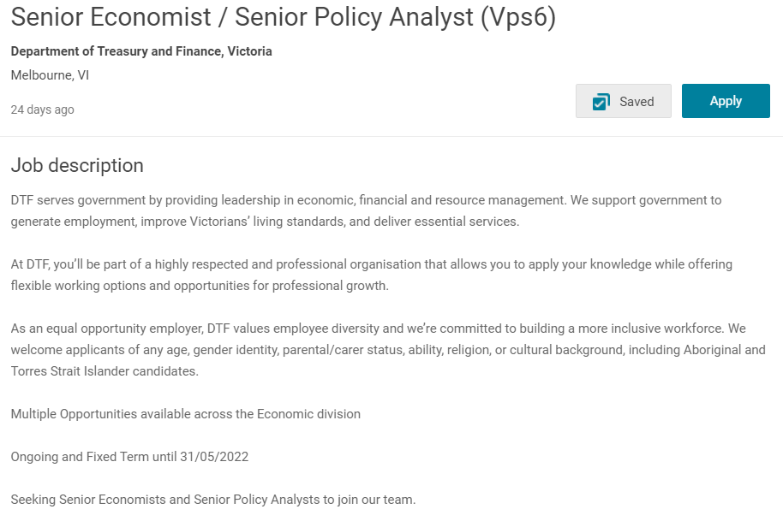

what this job is basically working as a part of a team that looks at the local environment (Victoria in this case) and seeing where its heading, what we are utilising and what we are not to make a more efficient, safer, better quality of life for all Victorians.

this is very appealing to me practically as it’s a good cause

sometimes in fiancé and the business world it’s a dog eat dog almost unsavoury climb to the top however this type of work is using the knowledge to apply it in a useful and helpful way.

the qualifications for this job aren’t specified, but it world likely entail a bachelors or masters degree in business and economics.

currently I don’t have either but I am looking to finish my bachelors electing in economics macro and micro to give myself the best chance of landing a great job.

these are the results from the personality test

<https://www.16personalities.com/profiles/60f6119f1c597>

learning style test

[I am a Visual-ISFP learner | Language Learning Style Quiz | Live Lingua](http://www.learningstylequiz.com/quiz/results/Visual-ISFP/47404)

Creativity test

[Free online creativity test - TestMyCreativity](http://www.testmycreativity.com/)

I got a score of 60

I don’t think these tests exactly affect my behaviour in any way other then an insight into compatibility with others, as any result is neither right nor wrong, I think it’s a good starting place for testing if teams will be compatible as certain personality types do clash and cause conflict.

PROJECT IDEA  
I had some trouble with this one as I wanted to somehow involve the business world as that’s my background and what I’m good at, I spent a lot of time thinking what avenue to go down but I keep coming back to app design, I found it seemed the most applicable and user friendly as the corporate business world can be very fast paced, people don’t have time to stop and use laptops and sift through websites so I kept falling back on a app based program for smart phones.

There’s so many apps out there currently for trading shares watch lists for assets and speculative investments, but what if there was a risk-free way to try all these things with no loss to yourself or to company’s shares a app where it lets you invest in the stock market with virtual purchases and money meaning you could invest with 100,000 dollars with no risk to you or company, no profit will be made as its not real money but it will allow especially young investors to try out there skills before using there hard earned money.

There are almost 5 billion shares sold and brought each day on the asx “the Australian stock exchange” this would been even higher if not for new investors being potentially scared off by the risk of loss and inability to practice their skills, while there are some options online to use virtual accounts these are often short free trials or you have to pay for them, this almost lapse in availability could open a door to so many things within the app market .

This product would be based on an easy-to-use free app that tracks simple data and market conditions, with profile setups features this would include trade history, performance history, account balance and account bests in a sense you could make this app interactive and almost a game/competitive environment with add friend options to share and watch you and others performance, this is all based off the performance of the share market so you invest in said shares and those shares go up or down in conjunction with the real world.

this app design not only could be simple and effective but is almost a canvas to work with this means design options are unlimited.

Setbacks to this app would be interactivity and making the app more appealing to people outside of novice investors.

Software’s that could be utilised to create such an app would be things like adobe xd which allows app designers to build and create apps without having to code it meticulously themselves.

Skills required would be the ability to write and finalise the coding needed from such a project, to find the extra skills and programs will be hard but not impossible as many helps like options are available.

If this app where to be successful it would enable younger or less experienced investors try their luck and skills at the real thing without having to do the real thing just yet, this would eliminate the bulky webpage sign up designs seen previously online and create a easy fast smarter way to practice.